Barlby Community Primary School
Low Level Concern Policy

Document Status
Date of Next Review | December 2024 | Responsibility | Full Governing Body
Success Criteria for review completion | Minutes of GB Meeting | Responsibility
Date of Policy Creation  2011 | Adapted school written model | Responsibility
Date of Policy Adoption by Governing Body  January 2023 |  | Signed  Headteacher  Chair of Governors
Method of Communication Noticeboard, Policy File and T-drive

Contents

- Introduction
- Summary
- Keeping Children Safe in Education September 2022
- Clarity around Allegation vs Low-Level Concern vs Appropriate Conduct
- Storing and use of Low-Level Concerns and follow-up information
- Process to follow when a Low-Level Concern is raised
- Low Level Concern Form

Introduction

At Barlby Community Primary School, we aim to create an open and transparent culture where all concerns about all adults involved with our school are dealt with promptly and appropriately. We aim to identify any concerning, problematic or inappropriate behaviour early; minimise the risk of abuse; and ensure that adults working in or on behalf of our school are clear about professional boundaries and act within these boundaries, and in accordance with our school ethos.
This policy should be read alongside our Child Protection Manual and Staff Guidance for Safer Working Practice Documents.

Summary

It may be possible that a member of staff acts in a way that does not cause risk to children, but is however inappropriate. A member of staff who has a concern about another member of staff, volunteer, contractor or who on reflection, recognises that their actions could have been viewed as a risk should inform the Head Teacher about their concern using a Low-Level Record of Concern Form. In the Head Teacher’s absence, the Deputy Safeguarding Lead should be contacted instead. If both Head and DSL can not be contacted then the Designated Safeguarding Lead Governor should be contacted.

Keeping Children Safe in Education September 2022

The following is taken from Keeping Children Safe in Education September 2022 and identifies what may be considered behaviour relating to low level concern:

423. Governing bodies and proprietors should have policies and processes to deal with any concerns or allegations which do not meet the harm threshold, referred to in this
guidance as ‘low-level’ concerns. It is important that schools and colleges have
appropriate policies and processes in place to manage and record any such concerns
and take appropriate action to safeguard children.

424. As part of their whole school approach to safeguarding, schools and
colleges should ensure that they promote an open and transparent culture in which all
concerns about all adults working in or on behalf of the school or college (including
supply teachers, volunteers and contractors) are dealt with promptly and appropriately.

425. Creating a culture in which all concerns about adults are shared responsibly and
with the right person, recorded and dealt with appropriately, is critical. If implemented
correctly, this should:

• enable schools and colleges to identify inappropriate, problematic or concerning behaviour early
• minimise the risk of abuse, and
• ensure that adults working in or on behalf of the school are clear about professional boundaries and act within these boundaries, and in accordance with the ethos and values of the institution.

What is a low-level concern?

426. The term ‘low-level’ concern does not mean that it is insignificant. A low-level
concern is any concern – no matter how small, and even if no more than causing a sense
of unease or a ‘nagging doubt’ - that an adult working in or on behalf of the school or
college may have acted in a way that:

• is inconsistent with the staff code of conduct, including inappropriate conduct outside of work and
• does not meet the harm threshold or is otherwise not serious enough to consider a
referral to the LADO.

Examples of such behaviour could include, but are not limited to:

• being over friendly with children
• having favourites
• taking photographs of children on their mobile phone, contrary to school policy
• engaging with a child on a one-to-one basis in a secluded area or behind a closed door, or
• humiliating children.

427. Such behaviour can exist on a wide spectrum, from the inadvertent or thoughtless,
or behaviour that may look to be inappropriate, but might not be in specific
circumstances, through to that which is ultimately intended to enable abuse.

428. Low-level concerns may arise in several ways and from a number of sources. For
example: suspicion; complaint; or disclosure made by a child, parent or other adult within
or outside of the organisation; or as a result of vetting checks undertaken.

429. It is crucial that all low-level concerns are shared responsibly with the right person
and recorded and dealt with appropriately. Ensuring they are dealt with effectively should
also protect those working in or on behalf of schools and colleges from becoming the
subject of potential false low-level concerns or misunderstandings.

Clarity around Allegation vs Low-Level Concern vs Appropriate Conduct

Allegation:
Any adult linked to our school who has:
- behaved in a way that has harmed a child, or may have harmed a child and/or;
- possibly committed a criminal offence against or related to a child and/or;
- behaved towards a child or children in a way that indicates he or she may pose a risk of harm to children; and/or
- behaved or may have behaved in a way that indicates they may not be suitable to work with children.
Low Level Concern:
Any adult linked to our school who has behaved in a way that:
- is inconsistent with the staff code of conduct, including inappropriate conduct outside of work; and
- does not meet the allegations threshold or is otherwise not considered serious enough to consider a referral to the LADO.
Appropriate:
- Behaviour which is entirely consistent with our school’s Code of Conduct, and the Law.

- Storing and use of Low-Level Concerns and follow-up information

Low Level Concern forms and follow-up information will be stored securely within the schools safeguarding systems, with access only by the leadership team. This will be stored in accordance with the school’s GDPR and data protection policies.
The staff member(s) reporting the concern must keep the information confidential and not share the concern with others apart from the Head Teacher or those aware in the senior leadership team.

Low-Level Concerns will not be referred to in references unless they have been formalised into more significant concerns resulting in disciplinary or misconduct procedures.

Whenever staff leave Barlby Community Primary School, any record of low-level concerns which are stored about them will be reviewed as to whether or not that information needs to be kept.

Consideration will be given to:

  - whether some or all of the information contained within any record may have any reasonably likely value in terms of any potential historic employment or abuse claim so as to justify keeping it, in line with normal safeguarding records practice; or
  - if, on balance, any record is not considered to have any reasonably likely value, still less actionable concern, and ought to be deleted accordingly

Process to follow when a Low-Level Concern is raised
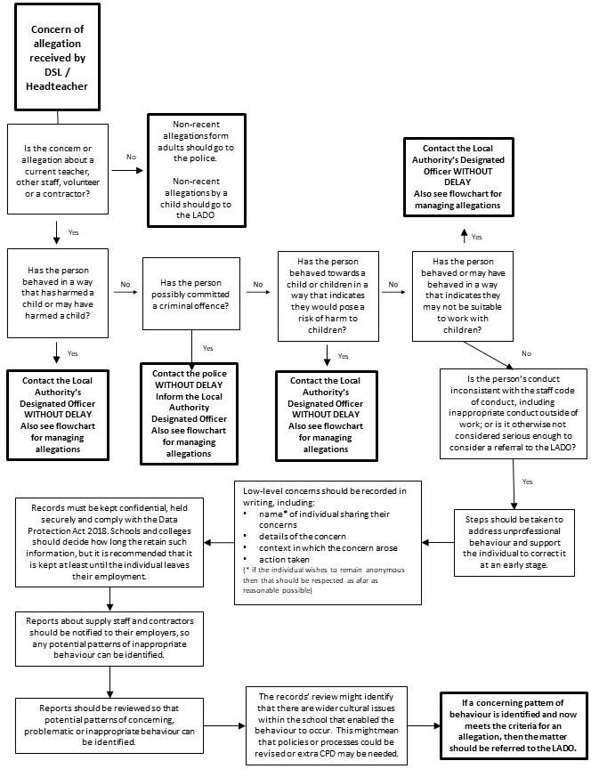

*NB – if the concern is about the Headteacher, then the Chair of Governors should be informed.

- Low level Concerns Reporting Form – Barlby Community Primary School

Your details
Name
Role
Date and time of completing this
form
Details of individual whom the concern is about
Name
Role
Relationship to the individual
reporting eg manager, colleague
Details of concern
Please include as much detail as possible. Think about the following:
- What behaviour and/or incident are you reporting?
- What exactly happened?
- Why does the behaviour and/or incident worry you?
- Why do you believe the behaviour and/or incident is not consistent with our Staff Code of Conduct?
Details of any children or young people involved
Name(s)
Next Steps
Are you willing to meet with the headteacher and DSL to discuss your concern? Please circle as  appropriate. | Yes | No
Please state any other information that you feel is relevant to the processing
of this concern.
Signature

For use by HT/safeguarding team upon receipt of the concern
Date and time concern received
Signature
Role
Actions to be taken and follow-up.

