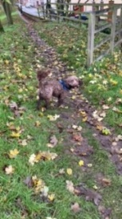
A day in the life of Bernie – Barlby C P School Dog

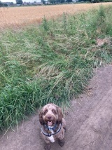
The most exciting time of the day, 6 O’ clock I get to go on my ‘River Bank Walk’. I get to run free for an hour chasing balls, birds and anything else that moves. I do like to roll in the mud but that seems to upset Mrs Baker, she tells me there is no time for that on a school day.

I arrive at school around 8am. I get to go for a sniff in all the classrooms on a long lead and say hello to all the adults in school. Lots of tickles at this point – I LOVE IT!

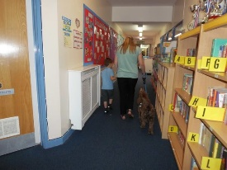
I start work at 8.45 and go with my adult to meet and greet a class of children. It’s always a surprise which class we are going to. The children always come in quietly and sit down on their chairs. I wait with my adult in the classroom and then when my adult says it’s ok, the children get to come and stroke me – just Lovely!

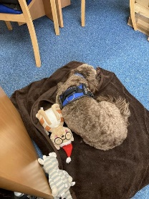
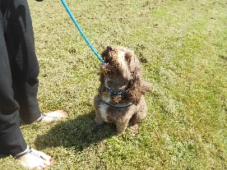
From 9am I wait in Mrs Baker’s office until I am needed to help with individual children or small groups. Mrs Baker says I can go in classroom to listen to reading very soon. I maybe go out to see these children 4 or 5 times each morning. Sometimes I sit in the corridor with them and help them start their learning, sometimes we go outside and play, other times I just sit in the office and the children come to me, I listen to them read and see them get stickers. I like to listen to the children talking and I always like to see them smile. If they are upset, I try and rest my chin on them, I hope this makes them feel a bit better.

At around 12 o clock Mrs Martin takes me for a long walk, I sniff my way around the village. Please come and say hello if you see us. Mrs Martin tell me she is learning lots about Barlby when we are out walking.

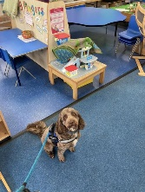
My afternoon is a lot like my morning, I wait for more children that need me to help them. Sometimes Mrs Baker has a meeting and I get to wait in Mrs Martin’s and Mrs Edgar’s office, they are always good for a treat. Sometimes I get to go to the meetings, I like all the people they make a fuss of me.

Being at school makes me very tired, that is why I am not here every day. I nap for most of the evening when I get home. Sometimes I go back out for a walk other times I play in the garden with George, he’s my big human brother.

I really enjoy being a school dog, I have so many friends here at Barlby Community Primary School.

