Barlby Community Primary School

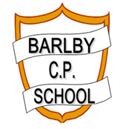
3 Year Strategic Plan

September 2023 – July 2026

Achievement | Curriculum | Leadership | Partnerships
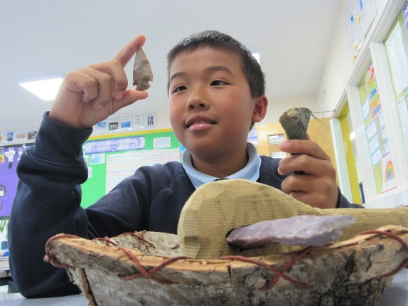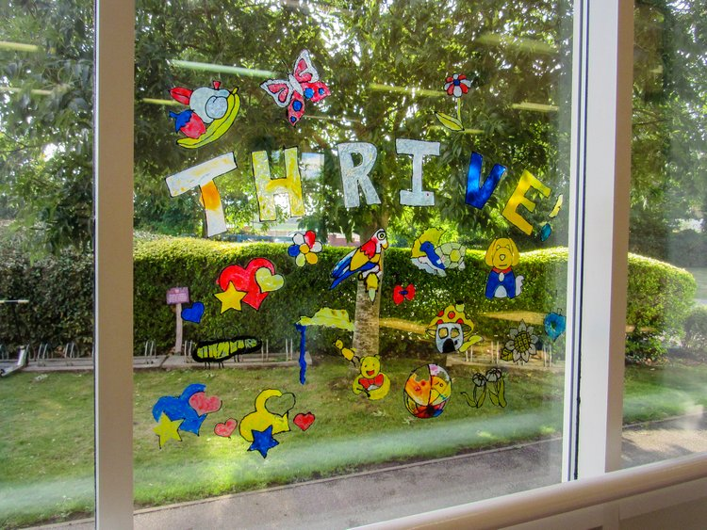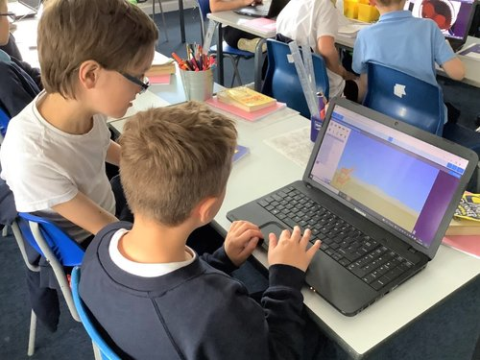

Our motto:

‘Together we achieve’
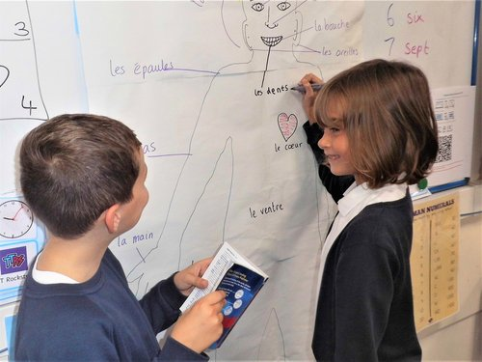

Barlby Community Primary School Vision

At Barlby Community Primary School our intention is to create
an environment in which all children are enabled to fulfil their
potential and feel pride in their identity. To achieve this, we
will aim to prepare children to reach their full potential
as responsible citizens in an increasingly complex world.

Our School Aims

We will provide our children with opportunities to…..
- Enjoy coming to school in an environment where they are safeguarded, happy, healthy, valued and secure.
- Experience a dynamic, creative and rich curriculum that meets their unique needs.
- Develop a desire and curiosity towards learning
- Be challenged and motivated to become lifelong learners.
- Value, appreciate and celebrate everyone’s talents
- Respect and take personal responsibility for their actions and environment,
- Develop an awareness of spiritual, moral, social and cultural issue
- Work in partnership with the whole school community
- Become effective, proficient lifelong readers

Barlby Community Primary School Strategic Goals 2023-2026

  - ACHIEVEMENT: Children reach the highest levels of achievement and personal development across the curriculum.
  - CURRICULUM: Children develop a love of learning skills for life through a highly engaging and, meaningful curriculum
  - LEADERSHIP: Leaders are highly ambitious and have an uncompromising drive to ensure the highest levels of achievement for all.
  - PARTNERSHIP: Children’s wider learning experiences are developed to promote their wellbeing for today and for the future.

Barlby Community Primary School Success Criteria 2023-2026 : What we want to do…..

Achievement | Strategic Goal 1: Children reach the highest levels of achievement and personal development across the curriculum.  Success Criteria:  - The percentage of children meeting and exceeding AREs in EYFS, KS1 and 2 English and Mathematics is consistently inline with, or above National and LA average  - All vulnerable and SEND children achieve personal aspirational targets  - The very large majority of children meet or exceed the National Curriculum expected level of attainment in Computing and Science at the end of KS1 and KS2.  - Quality of education in all subjects including EYFS is judged to be good across the school with a large majority being graded as outstanding.  - Intervention groups are highly effective in closing the learning gaps with 90%+ of children meeting personal targets.  - Home learning and parental engagement is highly effective with 90%+ of parents/carers attending parent meetings twice a year, plus additional meetings for individual children as required, including the completion of IPMs.  - Children act as role models and share their learning with others locally, nationally and internationally.  - Our learning environment and school website are of a very high quality and celebrate our high expectations across the school.
Curriculum | Strategic Goal 2: CURRICULUM: Children develop a love of learning skills for life through a highly engaging and, meaningful curriculum  Success Criteria:  - Outstanding curriculum provision enables meaningful cross-curricular links.  - Opportunities for child led, independent learning that will equip children with skills for life.  - Opportunities for enterprise, problem solving and innovation.  - Memorable and enjoyable learning experiences for all through themed curriculum days and visits/visitors.  - High levels of attainment, progress and challenge, with English and Maths skills applied across the curriculum.  - Teachers and children are given flexibility to allow children’s interests to be pursued through a creative planning approach.  - Outdoor learning and Forest School embedded.  - High quality, innovative Computing provision with learning and skills linked across the curriculum.  - Highly effective core and foundation teams to drive an outstanding curriculum.

Leadership | Strategic Goal 3: Leaders are highly ambitious and have an uncompromising drive and to ensure the highest levels of  achievement for all children. Success Criteria:  - Staff morale is high as a result of all leaders actively seeking to motivate staff through positive encouragement and celebration of staff achievements.  - Staff at all levels are engaged in continued personal and professional development.  - Co-coaching is used effectively to develop outstanding practice across the school the sharing of good practice across the cluster.  - All stakeholders are actively involved in the work of the School Development Plan and it is a highly effective tool for school improvement.  - 95%+ of children and their parents agree that the school is well led and managed.  - The Governing Body evaluates their effectiveness regularly and systematically challenges senior leaders to ensure the strategic development of the school and governance is outstanding.  - Safeguarding policy and procedures are evaluated to be outstanding. A safeguarding culture across the school is established where staff understand their responsibilities and recognize that safeguarding is everyone’s responsibility.
Partnerships | Strategic Goal 4: Children’s wider learning experiences are developed to promote their wellbeing for today and for the future.  Success Criteria:  - The school hosts regular parent workshops for English, Maths, Assessment, Transition and E-Safety and these are well attended by parents.  - Homework model is innovative and exciting for children with appropriate challenge for all ages and stages of learning.  - Annual open lessons allow children’s achievements to be celebrated.  - Parents are provided with clear and timely information about their child’s learning and progress and have a clear understanding of the age related expectations through the sharing of white folders (assertive mentoring).  - Children’s wellbeing and welfare needs are fully met through high quality advice, support and guidance to parents from school staff.  - School attendance is high (97%+) and the school works closely with parents if there are concerns or worries to address these swiftly.

Barlby Community Primary School Milestones & Key Objectives: How are we going to do it…..
Goals | 2023-2024 |  | 2024-2025 | 2025-2026
Goal 1: Achievement | English | - School to perform in line with, or better than, national average in Reading, GPS and Writing in end of Key Stage results.  - 25% or more of children achieve the higher standard in each area in each year.  - Percentage of children in all other year groups, achieving or exceeding AREs in Reading, GPS and Writing, is above national average for Key Stage SAT data.  - EYFS Reading and Writing EGL remain inline or above National and LA averages  - Embed adopted phonics scheme from EYFS to year 1(RWInc) | - School to perform in line with, or better than, national average in Reading, GPS and Writing in end of Key Stage results.  - 25% or more of children achieve the higher standard in each area in each year.  - Percentage of children in all other year groups, achieving or exceeding AREs in Reading, GPS and Writing, is above national average for Key Stage SAT data.  - EYFS Reading and Writing EGL remain above National and LA averages  - CPD to be led by EEF research and toolkit | - School to perform better than, national average in Reading, GPS and Writing in end of Key Stage results.  - 30% or more of children achieve the higher standard in each area in each year.  - Percentage of children in all other year groups, exceeding AREs in Reading, GPS and Writing, is above national average for Key Stage SAT data.  - EYFS Reading and Writing EGL remain above National and LA averages  - Greater opportunity for peer-coaching and collaboration across school. Skilled staff to model approaches, lessons and delivery.
 | Maths | - School to perform in line with, or better than, national average in Maths in end of Key Stage results.  - 25% or more of children achieve the higher standard in each area in each year.  - Percentage of children in all other year groups, achieving or exceeding AREs in Maths, is above national average for Key Stage SAT data.  - EYFS Maths EGL to remain above LA averages  - Further develop the use of mastery approaches across all year groups.  - Fluency built into daily sessions | - School to perform in line with, or better than, national average in Maths in end of Key Stage results.  - 25% or more of children achieve the higher standard in each area in each year.  - Percentage of children in all other year groups, achieving or exceeding AREs in Maths, is above national average for Key Stage SAT data.  - EYFS Maths ELG remains above LA averages  - Cascade training for mastery in number across all year groups  - CPD to be led by EEF research and toolkit | - School to perform better than, national average in Maths in end of Key Stage results.  - 30% or more of children achieve the higher standard in each area in each year.  - Percentage of children in all other year groups, exceeding AREs in Maths, is above national average for Key Stage SAT data.  - EYFS Maths ELG remains above LA average.  - Greater opportunity for peer-coaching and collaboration across school. Skilled staff to model approaches, lessons and delivery.
 | Other | - Foundation subjects teaching, learning and assessment judged to be good or outstanding.  - Review of home learning to make it a more purposeful, meaningful shared learning experience.  - Members of school SLT to embed NPQ knowledge and practice through new school initiatives. | - Continue dedicated time for collaboration between subject leaders to identify, plan and develop cross curricular links further. | - Sharing of good practice with others through larger community presence.

Goals | 2023-2024 | 2024-2025 | 2025-2026
Goal 2: Curriculum | - Hold an KS2 animation week utilising skills taught through computing.  - Within school, reschedule and hold planned ‘camp-out’ festival.  - Embed ‘forest schools campus’ within the national curriculum.  - Embed subject leader awareness for new and emerging subject leaders to ensure succession planning.  - Children to lead an enterprise (e.g. sell/eat produce from the school garden and further promote healthy eating and sustainability across the school).  - Promote British values, tolerance, acceptance and faith across the curriculum. Ensure children have opportunity to continue to broaden cultural horizons through visits and visitors to/from places and people with backgrounds and faiths different to their own. | - Hold jobs jamboree.  - Whole school curriculum days – staff to plan, host and run three (one each term) curriculum days. The days will be about areas not covered by the school curriculum. These will include a launch assembly, challenges and activities.  - Promote British values, tolerance, acceptance and faith across the curriculum. Ensure children have opportunity to continue to broaden cultural horizons through visits and visitors to/from places and people with backgrounds and faiths different to their own. | - Further promote British values, tolerance, acceptance and faith across the curriculum. Ensure children have opportunity to continue to broaden cultural horizons through visits and visitors to/from places and people with backgrounds and faiths different to their own.  - Carry out full curriculum review:  Does the current format still meet the needs of the children school?  Revisit and plan cross-curricular links utilizing new expertise.  - Act on findings from the curriculum review

Goals | 2023-2024 | 2024-2025 | 2025-2026
Goal 3: Leadership | - Member(s) of SLT implement learnings from NPQH training.  - Review annual safeguarding audit to ensure provision remains outstanding.  - Governors self assessment continues to be graded good or better.  - School council and pupil voice. School staff to suggest and decide upon meaningful tasks to give true purpose and sense of voice.  - Subject leaders to continue to take additional control and responsibility over subject (facilitated through training and improved knowledge of assessment).  - Review succession planning – development of leaders at all levels. | - Governors to shadow subject leaders during monitoring cycles to develop greater understanding of the monitoring process.  - Governors self assessment to be graded outstanding.  - Leadership in school to be graded as outstanding.  - School leaders to arrange for celebration of staff within school – recognition of teamwork and ethic.  - Focused CPD for areas of the curriculum most in need of development.  - Continue to increase pupil voice around school: displays to include quotes from children; library features peer recommendations; school council to meet with governors (Building on speaking and literacy/vocabulary work in English) | - Leadership and management to remain outstanding.  - Governors self assessment continues to be graded outstanding.  - Strengths within school – teaching of foundations subjects and areas to be formally shared with schools within the cluster.

Goals | 2023-2024 | 2024-2025 | 2025-2026
Goal 4: Partnerships | - Further develop activities to enhance children’s learning experiences during the school holidays.  - Host re-scheduled ‘cultural camp out’  - Review transitions from Nursery to EYFS, Year2 to Yr 3 and Yr 6 to Yr 7. Develop a programme of transition activities for parents/carers and use in school.  - Further THRIVE (Nurture system) training and support to establish consistent pupil profiling across the school.  - Develop core skills workshops for parents to learn alongside their child.  - Increase parental attendance to academic focused sessions and workshops.  - Review of home learning to make it a more purposeful, meaningful shared learning experience. | - Develop partnerships with local places of worship, local businesses and parent skill sets:  Use knowledge of parents and local associations to further build school allotments and wildlife/forest school areas.  Develop further church links and maintain current associations.  Continue with community involvement.  - To review school webpage to show clear progression in each subject across whole curriculum.  - Establish action plan for involvement of pre-school children with school community (library access – groups – activities)  - Continue links with teacher training schemes and universities to help further the development of the profession. | - To continue to develop use of school website and other online platforms in engaging parents with academic achievement:  Youtube/Video sharing sites used to record methods for mathematics or explanations of grammatical concepts.  - Explore possibility of sponsorship or funding for curriculum subjects/sporting events from businesses.

